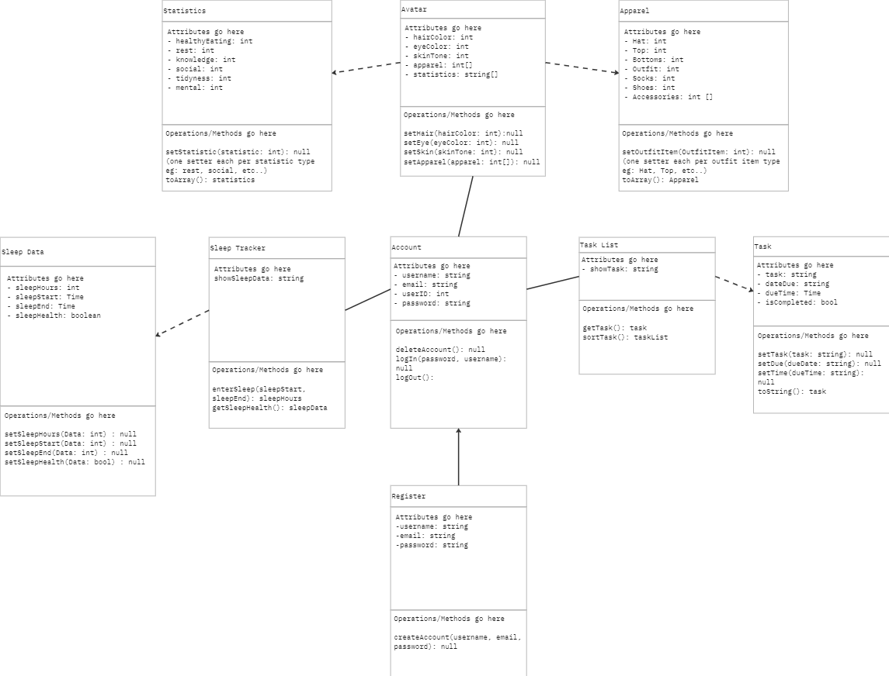

Domain Model for Team-E

The most important part of our model is the Account in the center. It links to all the data attached to the user. It will populate the app with the user's data allowing them access and to use it while logged in. The application connects the user with this data in 3 ways. It allows them access to the tasks they have set and lets them create, delete, and edit them. It lets the user view and customize their avatar, see its stats, and get feedback on tasks. It also gives them access to a sleep tracker they can use to make sure they keep a healthy sleep schedule. These functions are used to help promote a healthier lifestyle, by increasing the statistics of the avatar and providing feedback where necessary.

* **Register**
  + username: string
  + email: string
  + password: string
  + createAccount(username, email, password): null
* **Account**
  + username: string
  + email: string
  + userID: int
  + password: string
  + deleteAccount(): null
  + logIn(password, username): null
  + logOut():
* **Task List**
  + showTask: string
  + getTask(): task
  + sortTask(): taskList
* **Task**
  + task: string
  + dateDue: string
  + dueTime: Time
  + isCompleted: bool
  + setTask(task: string): null
  + setDue(dueDate: string): null
  + setTime(dueTime: string): null
  + toString(): task
* **Avatar**
  + hairColor: int
  + eyeColor: int
  + skinTone: int
  + apparel: int[]
  + statistics: string[]
  + setHair(hairColor: int):null
  + setEye(eyeColor: int): null
  + setSkin(skinTone: int): null
  + setApparel(apparel: int[]): null
* **Apparel**
  + Hat: int
  + Top: int
  + Bottoms: int
  + Outfit: int
  + Socks: int
  + Shoes: int
  + Accessories: int []
  + setHat(Hat: int): null
  + setTop(Top: int): null
  + setBottoms(Bottoms: int): null
  + setOutfit(Outfit: int): null
  + setSocks(Socks: int): null
  + setShoes(Shoes: int): null
  + setAccessories(Accessories: []): null
  + toArray(): Apparel
* **Statistics**
  + healthyEating: int
  + rest: int
  + knowledge: int
  + social: int
  + tidyness: int
  + mental: int
  + setHealthyEating(healthyEating: int): null
  + setRest(rest: int): null
  + setKnowledge(knowledge: int): null
  + setSocial(social: int): null
  + setTidyness(tidyness: int): null
  + setMental(mental: int): null
  + toArray(): statistics
* **Sleep Tracker**
  + showSleepData: string
  + enterSleep(sleepStart, sleepEnd): sleepHours
  + getSleepHealth(): sleepData
* **Sleep Data**
  + sleepHours: int
  + sleepStart: Time
  + sleepEnd: Time
  + sleepHealth: boolean
  + setSleepHours(Data: int) : null
  + setSleepStart(Data: int) : null
  + setSleepEnd(Data: int) : null
  + setSleepHealth(Data: bool) : null